**AngularJS Docs\*\*\*\*\*\*\*\*\*\*\*\*\*\*\*\*\*\*\*\*\*\*\*\*\*\*\*\*\*\*\*\*\*\*\*\*\*\*\*\*\*\*\*\*\*\*\*\*\*\*\*\***

<https://docs.angularjs.org/api>

**Chrome \*\*\*\*\*\*\*\*\*\*\*\*\*\*\*\*\*\*\*\*\*\*\*\*\*\*\*\*\*\*\*\*\*\*\*\*\*\***

chrome.exe -allow-file-access-from-files -disable-web-security

chrome.exe -allow-file-access-from-files -disable-web-security

**Angular JS \*\*\*\*\*\*\*\*\*\*\*\*\*\*\*\*\*\*\*\*\*\*\*\*\*\*\*\*\*\*\*\*\*\*\*\*\*\*\*\*\*\*\*\***

MEAN Application

M –Mongo DB

E-Express JS

A-Angular JS[Widen Role]

N-Node JS

Above tech uses JS.

This makes client side development more powerful.

AJS Version 1.2.

AJS is MV * framework

What is and Why Angular JS?

**\*Closure\*\*\*\*\*\*\*\*\*\*\*\*\*\*\*\*\*\*\*\*\*\*\*\*\*\*\*\*\*\*\*\*\*\*\*\*\*\*\*\*\*\*\*\*\*\*\*\*\*\*\*\*\*\*\*\***

Self Invocation Of Function

**Notes\*\*\*\*\*\*\*\*\*\*\*\*\*\*\*\*\*\*\*\*\*\*\*\*\*\*\***

* Model has to be passed to view using scope object.
* Scope variable is only accessed in Controller.
* Controller using scope object pass model data to view.
* All Model object come from scope object
* In AngularJS every thing comes under scope object.
* $scope.compname=Igate. Here compname is a model
* View in AJS is compiled DOM.
* We have model and one time merge with view.
* Tag with ng-app is compiled dom.
* View is compiled dom.

**Module*****AngularJSModuleDemo_4.html\*\*\*\*\*\*\*\*\*\*\*\*\*\*\*\*\*\*\*\*\*\*\***

var mod=angular.module('SampleApp',[]);

<<<undefined>>>

For this module create a controller that is sample controller.

**RootScope\*\*\*\*\*\*\*\*\*\*\*\*\*\*\*\*\*\*\*\*\*\*\*\*\*\*\*\*\*\*\*\*\*\*\*\*\*\*\*\*\*\*\***

* Root scope is first one to get executed.
* Run method is used to kick start application.
* We can create a constant in run method.
* Variable available in a root scope will be available in the
* Do not place lot of data in root scope

**What is Injector Service?\*\*\*\*\*\*\*\*\*\*\*\*\*\*\*\*\*\*\*\*\*\*\*\*\*\*\*\*\***

* It is service single ton object used for dependency injection.
* Suppose we have var app=angular.module(“myapp”,[]);
* Function EmpControllee($scope){}. who create object of $scope in a controller. So injector service create the object of controller.
* Angular uses injector for managing look up and instantiation of dependency
* It is responcible for instantiation of module,controller and directives and it is used in framework.

**Config\*\*\*\*\*\*\*\*\*\*\*\*\*\*\*\*\*\*\*\*\*\*\*\*\*\*\*\*\*\*\*\***

* Interpolate provider is used to denote the expression.

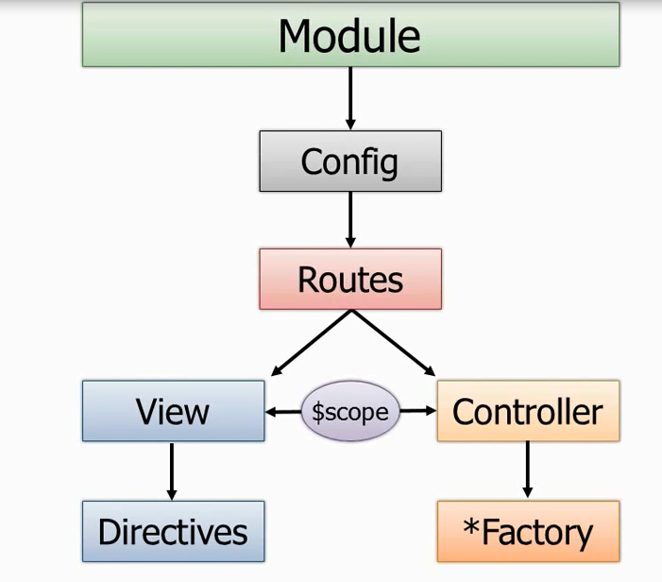

**\*\*\*\*\*\*\*\*\*\*\*\*\*\*\*\*\*\*Module***************.**

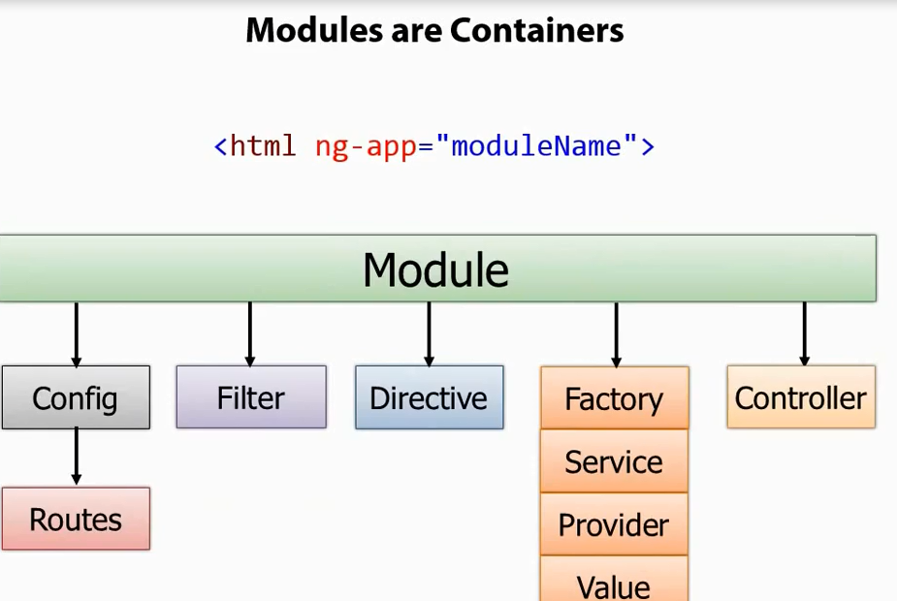

**\*\*\*\*\*\*\*\*\*\*\*angular.module(“Main Module,Second Parameter)\*\*\*\*\*\*\*\*\*\*\*\*\*\*\*\*\*\*\*\*\***

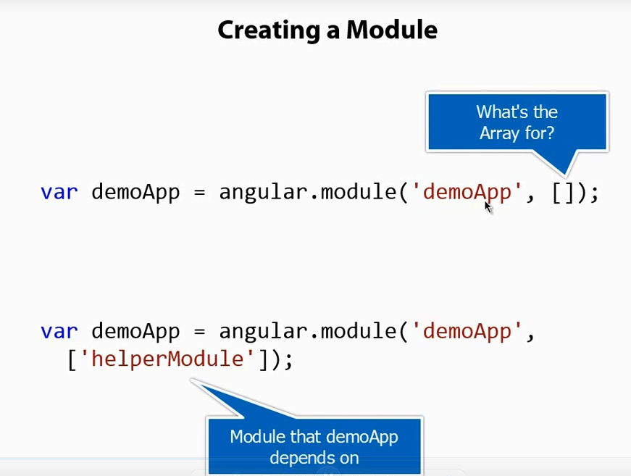

**\*\*\*\*\*\*\*\*\*\*\*\*\*\*\*\*Day-2 Directives\*\*\*\*\*\*\*\*\*\*\*\*\*\*\*\*\*\*\*\*\***

We r not suppose to do any dom manipulation in controller.

Controller should not own domain model means controller should get model data through service.

vaishaliFunctionDirective

so convention is